**Nurturing curiosity**

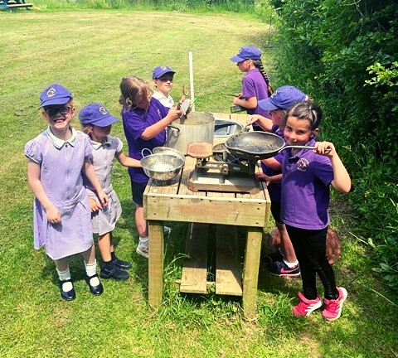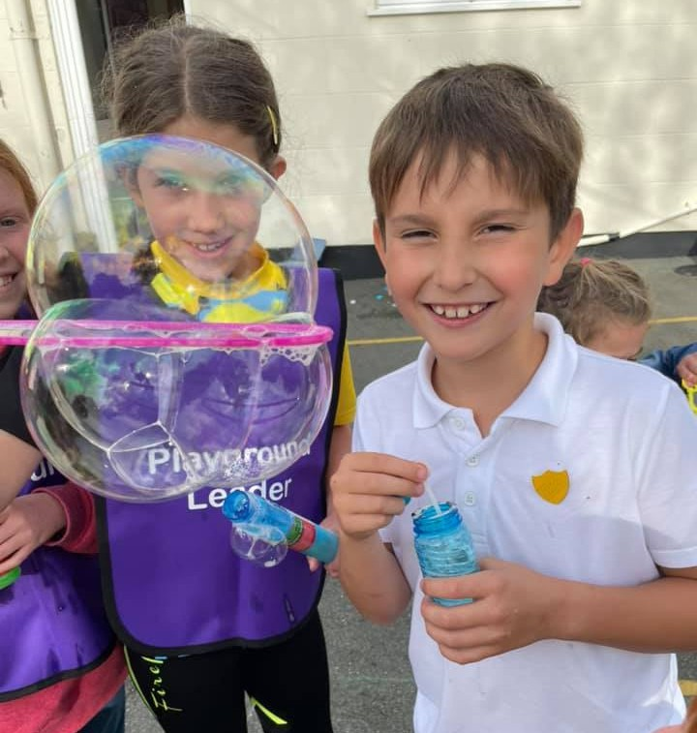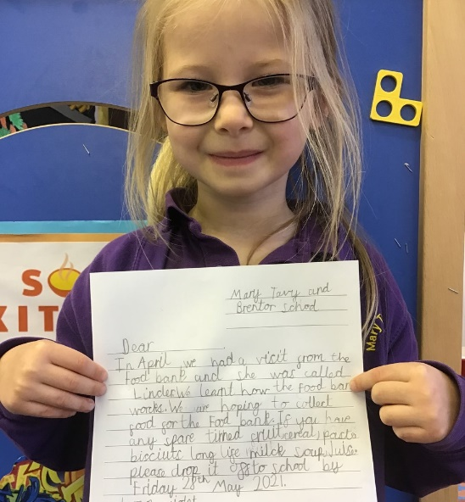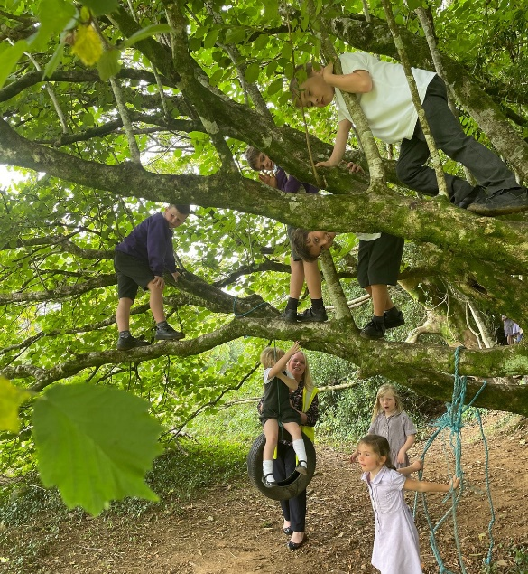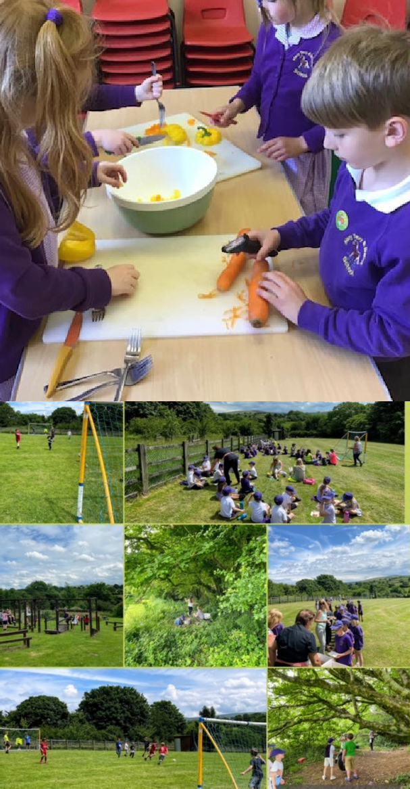

**School Governor Vacancy**

# Make a difference and become an MTB school governor.

# Support, inspire,

# change

# 

# 

An aspirational curriculum & learning excellence.

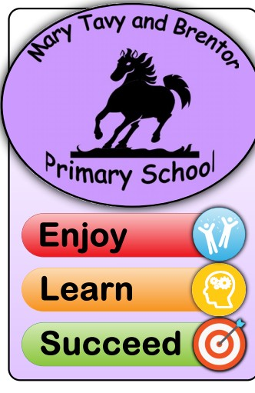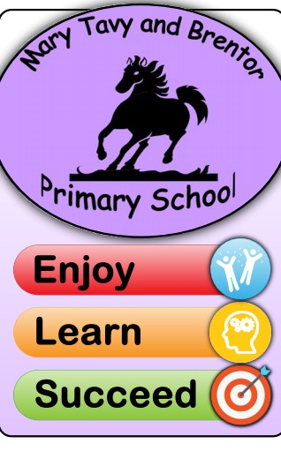A caring and inclusive school community.

Tel: 01822 810384

or email: [chair@marytavyandbrentor.devon.sch.uk](mailto:chair@marytavyandbrentor.devon.sch.uk)

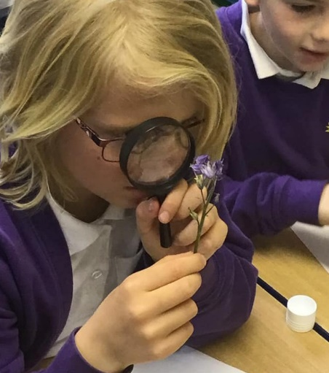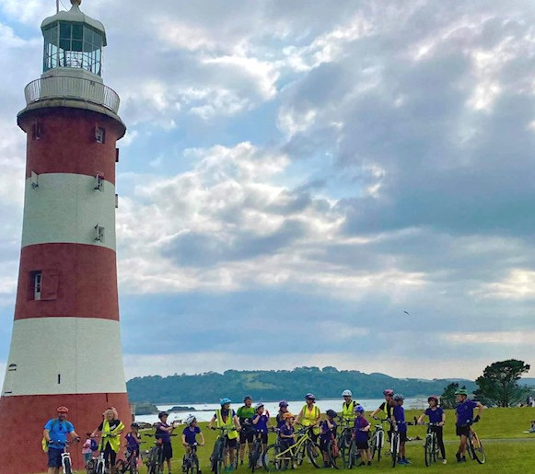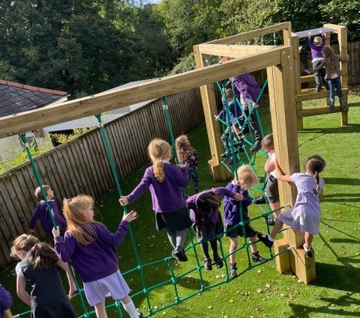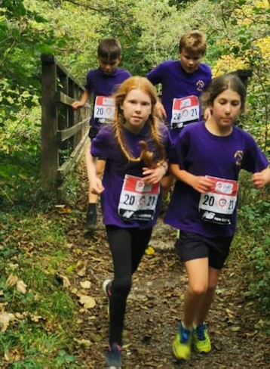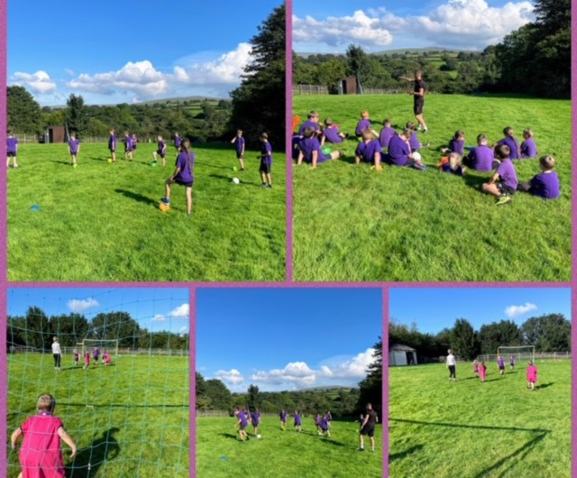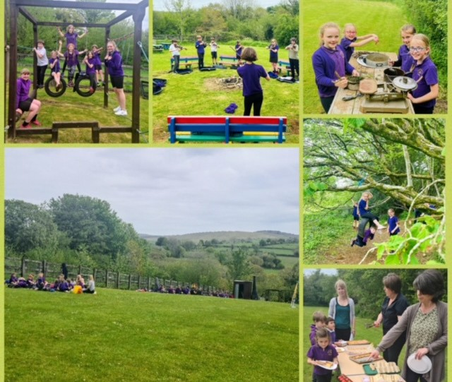

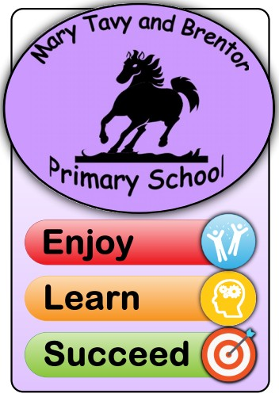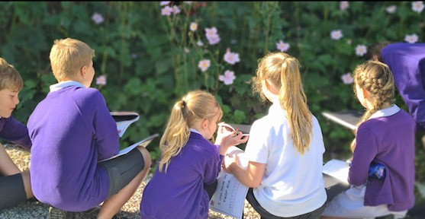

Mary Tavy and Brentor Primary School

Perseverance, Aspiration, Respect, Collaboration

Please come and join us and help shape our wonderful little school, where all our children are nurtured and their passions and interests enhanced. We are extremely proud of our cohesive, ambitious, creative and challenging curriculum.

Our extensive extra-curricular activities include Cross country running club, Bike club, STEM club, Musical Theatre, Coding, Choir and much ,much more.

We pride ourselves on academic, sporting and artistic excellence.

# We are seeking governors from our local community to promote and challenge our MTB Approach so that we can deliver educational excellence in our local area

Tel: 01822 810384 or email: [admin@marytavyandbrentor.devon.sch.uk](mailto:admin@marytavyandbrentor.devon.sch.uk)